SEND Support
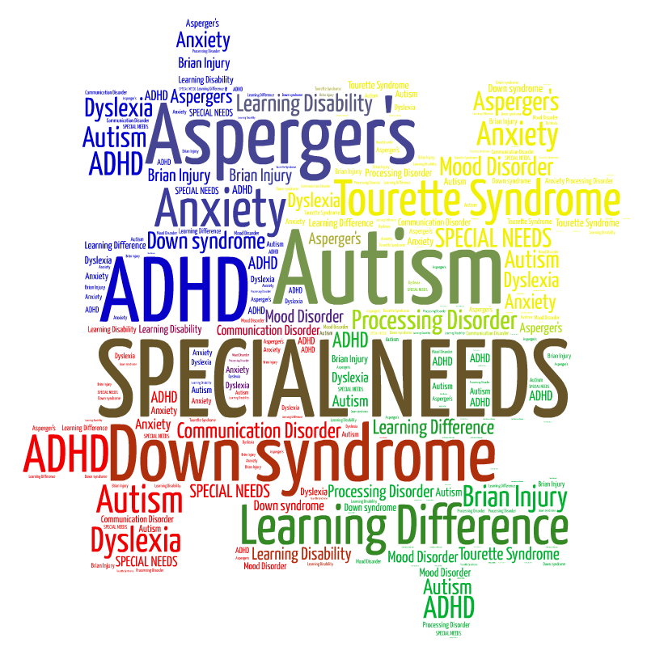
Helplines for Settings and Families In response to the current coronavirus pandemic, Liverpool Local Authority’s SEND Support Services would like to offer advice and support to our settings and families during this difficult time.

SENISS Helpline: 07591837693
If your child has special educational needs and you are wanting to know more on how to support their learning at home then please ring for professional advice, support or practical strategies.
Monday: 1pm – 4pm, Wednesday: 9am – 4pm, Friday: 9am – 12pm Alternatively, you can email your concern to seniss@liverpool.gov.uk

Educational Psychology Service Helpline: 0151 233 5978
If you are concerned about your child’s emotional wellbeing or managing their behaviour then please ring for professional advice, support or practical strategies. Monday to Friday: 9am – 4.30pm Alternatively, you can email your concern to epsadmin@liverpool.gov.uk

ASD Training Team:
07522800193/07515501854
Advice and strategies for families of children and young people with autism or social communication needs.
Monday to Friday: 9am – 12pm Alternatively, you can email your concern to ASDtrainingteam@liverpool.gov.uk

Children’s Occupational Therapy Service
Please contact the Children’s Occupational Therapist who is supporting the child for advice or alternatively for general enquiries please email chot@liverpool.gov.uk Liverpool Sensory Service Please contact the Sensory Specialist Teacher who is supporting the child for advice or alternatively for general enquiries please email sensoryservice@liverpool.gov.uk

Eating Disorders
One in fifty of us will experience binge eating disorder in our lifetime. It is the most common but least understood eating disorder. Share our video to help start the conversation this #Eating Disorders Awareness Week. #EDAW, #YouMightKnowMe.

https://www.youtube.com/watch?v= ZDAz6JTowxg&feature=emb_title

Beat’s Helplines are open 9am – 8pm weekdays and 4pm – 8pm weekends and bank holidays on 0808 801 0677. They support anyone affected by binge eating disorder, whether you’re worried about yourself or someone you know.

Liverpool Parent and Carers - LivPaC
https://fsd.liverpool.gov.uk/kb5/liverpool/fsd/service.page?id=68TVObiahRs

The Isabella Trust
The Isabella Trust is a registered charity which aims to provide information, support, training, courses and workshops to parents and carers of autistic children and children who experience sensory processing difficulties.

https://www.theisabellatrust.org/contact/

